Convolutional Neural Network
What is CNN?
- A Convolutional Neural Network (CNN) is a deep learning algorithm mainly designed to process image data.
- CNN is inspired by the human visual system.
- CNN is a neural network that can automatically learn features from images like edges, shapes, and objects.
- CNN is a deep learning model that uses convolution and pooling to extract image features and dense layers for classification.

Why CNN is Needed? (Problem with ANN)
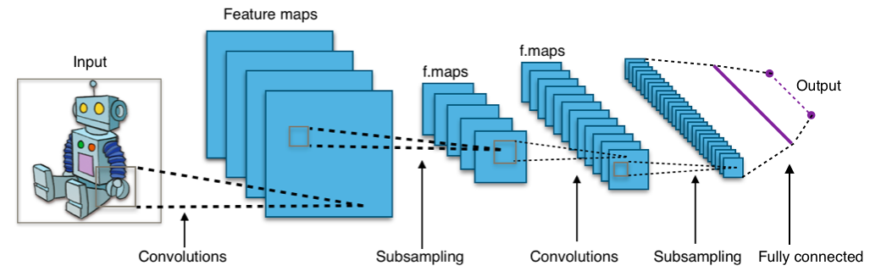
Problem with ANN for images
Example image:
- Size: 64 × 64 × 3
- Total inputs = 12,288 neurons
If we use ANN:
- Too many parameters
- Very slow training
- Overfitting
- No understanding of spatial relationship
❌ ANN treats all pixels equally
✅ CNN understands neighboring pixels

CNN Architecture (High-Level)
A CNN is divided into two main parts:
🔹 Part 1: Feature Extraction
- Convolution Layer
- Activation (ReLU)
- Pooling Layer
🔹 Part 2: Classification
- Flatten
- Fully Connected (Dense) Layers
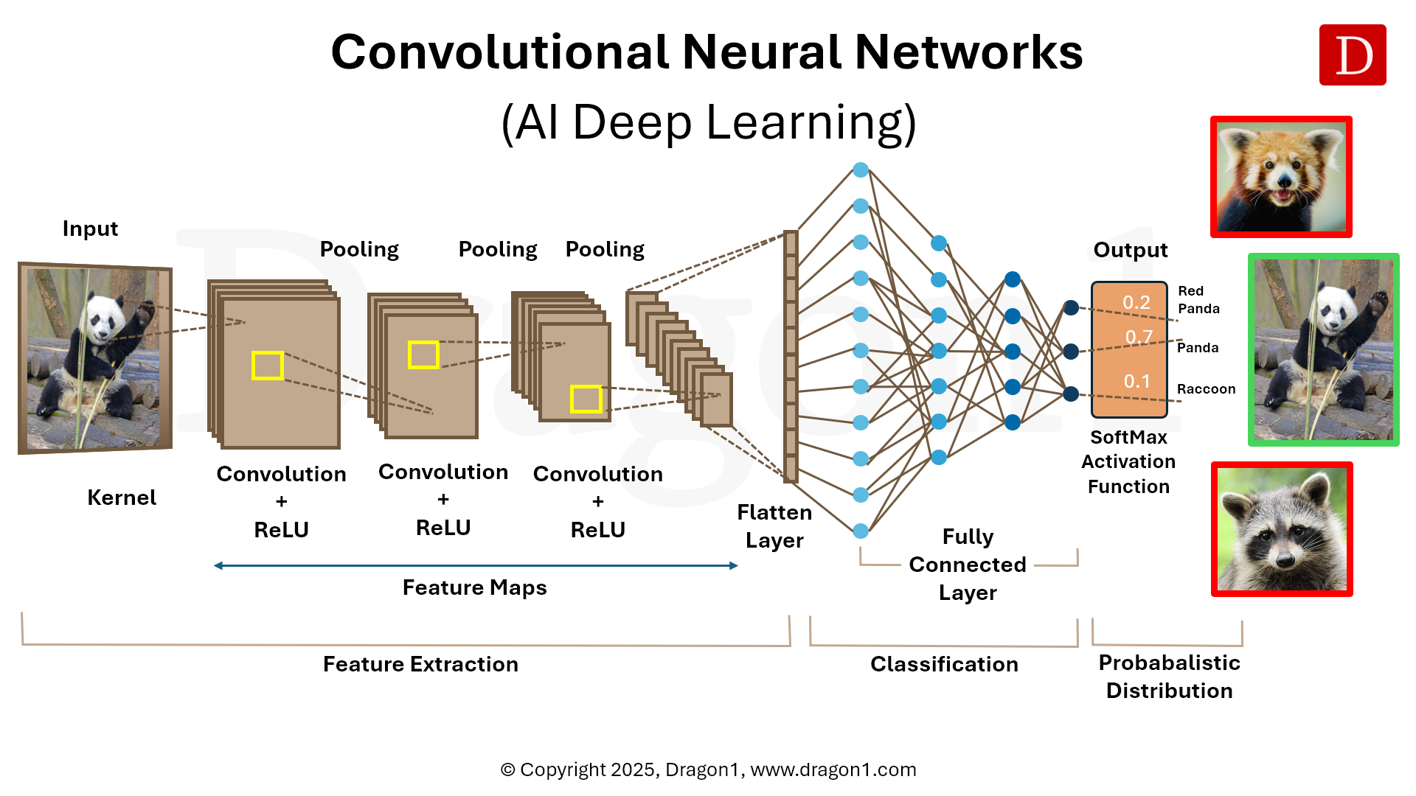
- Output Layer
Typical CNN flow:
Input Image
→ Convolution
→ ReLU
→ Pooling
→ Convolution
→ ReLU
→ Pooling
→ Flatten
→ Dense
→ Output

Convolution Layer (Core of CNN)
- Convolution means sliding a small matrix (filter/kernel) over an image to extract features. The Convolution Layer is the heart of a CNN.
- Its main job is to extract features from an image.
- The convolution layer looks at small parts of an image and finds important patterns like edges and shapes.
Example:
- Image size: 6×6
- Filter size: 3×3
- Output: Feature map
Each filter detects one specific feature:
- Vertical edge
- Horizontal edge
- Curve
- Texture
Key terms:
Term | Meaning
Kernel / Filter | Small matrix (3×3, 5×5)
Stride | Steps taken while sliding
Padding | Adding zeros around image
Feature Map | Output of convolution
Why convolution works?
It focuses only on local regions instead of the full image.

Kernel
- A kernel (also called a filter) is a small matrix of learnable weights used in the convolution layer.
- A kernel is a small window that moves over an image to detect specific features.
- CNN kernels are like students learning from mistakes.
- Initially they know nothing, but after many corrections, they become experts at finding patterns.
- In CNN, kernel values are randomly initialized and automatically learned during training using backpropagation and gradient descent.

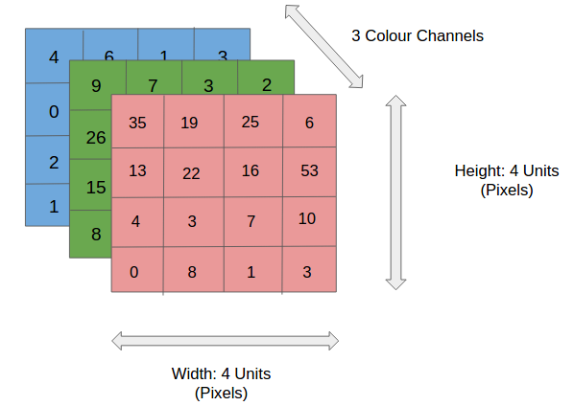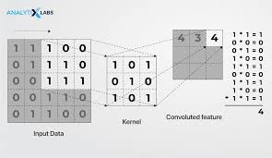
Range between 0-255
Why Kernel is Needed
Images are very large.
CNN does not look at the whole image at once.
Instead:
- Kernel looks at small local regions
- Finds patterns like:
  - edges
  - corners
  - textures
This makes CNN:
- Efficient
- Accurate
- Scalable

Kernel Size
Common kernel sizes:
- 3×3 (most popular)
- 5×5
- 7×7
Why 3×3 is preferred?
- Captures local details
- Fewer parameters
- Faster computation
- Deeper networks possible

How Kernel Works
Step 1: Kernel is placed on image
Step 2: Element-wise multiplication
Step 3: Sum all values
Step 4: Output one value
Step 5: Slide kernel and repeat
This operation is called convolution.
- Output is stored in a feature map.

Activation Function – ReLU
After convolution, we apply ReLU.
Formula:
ReLU(x) = max(0, x)
Why ReLU?
- Removes negative values
- Adds non-linearity
- Faster computation
- Solves vanishing gradient (partially)
📌 Without activation → CNN becomes linear (bad)

Pooling Layer (Downsampling)
Pooling reduces the spatial size of feature maps.
Most common: Max Pooling
Example:
2×2 window → take maximum value
Why pooling is important?
- Reduces computation
- Reduces overfitting
- Keeps important features
Types:
- Max Pooling (most used)
- Average Pooling

Multiple Convolution Layers
CNN uses multiple conv layers.
Feature learning hierarchy:
- First layers → edges
- Middle layers → shapes
- Deep layers → objects (face, car)
This is called hierarchical feature learning.

Flatten Layer
Before classification:
- Feature maps are 2D
- ANN needs 1D input
Flatten does:
[Height × Width × Channels] → [1D vector]
📌 No learning happens here

Fully Connected Layer
This part behaves like a normal ANN.
Purpose:
- Combine all learned features
- Perform classification
Output layer:
Problem | Activation
Binary classification | Sigmoid
Multi-class | Softmax

Loss Function in CNN
Loss tells how wrong the prediction is.
Task | Loss Function
Binary classification | Binary Crossentropy
Multi-class | Categorical Crossentropy

Backpropagation in CNN
CNN learns using:
- Forward pass
- Loss calculation
- Backpropagation
- Weight update using optimizer
Optimizers:
- SGD
- Adam (most common)

Simple CNN Example (Keras)
from tensorflow.keras.models import Sequential
from tensorflow.keras.layers import Conv2D, MaxPooling2D, Flatten, Dense

model = Sequential()

model.add(Conv2D(32, (3,3), activation='relu', input_shape=(64,64,3)))
model.add(MaxPooling2D(2,2))

model.add(Conv2D(64, (3,3), activation='relu'))
model.add(MaxPooling2D(2,2))

model.add(Flatten())

model.add(Dense(128, activation='relu'))
model.add(Dense(1, activation='sigmoid'))
Explain layer by layer in class.

CNN vs ANN vs RNN
Model | Best Used For
ANN | Tabular data
CNN | Images
RNN | Sequential data

Advantages of CNN
- Automatic feature extraction
- Less parameters than ANN
- High accuracy in image tasks
- Translation invariant

Limitations of CNN
- Needs large data
- High computational power
- Not suitable for tabular data

